Charles Nelson -- His Early Years

Introduction
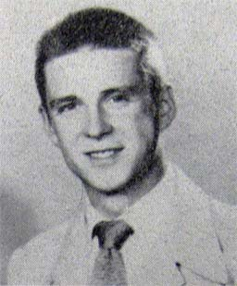
You are a 15-year-old Salina High School sophomore and enter a talent contest along with 15,000 other Americans of all ages (including professionals) from 20 other states of the Union. It culminates in a final competition in Hollywood among the best 9 aspirants with the promise of valuable prizes, a movie screen test, auditions with producers of shows, plus your hand and foot prints set in concrete at the Grauman’s Chinese theater beside the Hollywood famous. What chance would you, you at age 15 in windy Salina, Kansas, population 21,000, have of winning this huge talent contest?
For Charles Nelson of 705 W. Iron Ave. in 1949, his chance of winning against these odds turned out to be 100%. Here is the Charles Nelson story from 1949 on to 1960 as best I have been able to piece it together. (That's his senior class photo at age 17 on the right.)

High School Overview
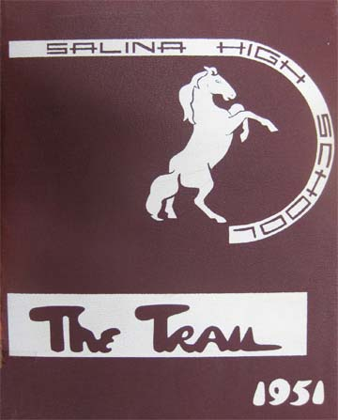
When he won the contest in the spring of 1949, he was described as a 15-year-old sophomore so he would have been a second semester sophomore. Photos in Trails show that he progressed normally through the high school grades, so he must have been born in the second half of 1933. For reasons I'll explain much later, I think the exact date was September 21, 1933.
The 1947 Trail shows him in a photograph with 8th graders. The 1948 Trail has him in a group photo of Freshmen, on a basketball team labeled as “Future Hoopsters,” and on the Freshman football squad.
The Trail for the pivotal year of 1949 (sophomore) is missing from the Salina library shelf as is the Trail for 1950 (junior).
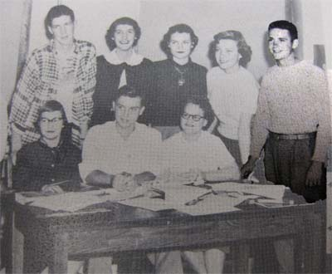
The 1951 Trail is available, thankfully, and this was his senior year after so much success with the contest, singing in a Broadway show, and appearances on radio and TV. Photos in this '51 Trail show him active as the football quarterback, a basketball guard, in a Gilbert and Sullivan operetta, a play, one of the students producing the Trail, and a member of the music club. The list of activities attributed to him shows an even busier year: “A Capella 3,4; Basketball 1,2,3,4; Chorus 1,2,3,4; Dramatics Club 3,4; Football 1,2,3,4; Hi-Y 1,2,4; Jr. Play; Letterman 3,4; Musicals 1,2,3,4; Music Club 3,4; National Athletic Society 3; National Junior Honor Society 2; Spanish Club 3; Student Council 1, Vice-President 4; Tennis 1,3; Thespian 3,4; track 1,2; Trail Staff 4." Baseball was not a school sport but other sources say he was also a pitcher on the American Legion team.
The photo on the right shows half the 1951 Trail staff, with Nelson highlighted on the far right. Even as a senior in this photo, two years after the contest, would you expect a strong baritone voice from him?
Despite all the huge distractions in 1949 with the contest and the subsequent appearances, he kept his schooling going and graduated in 1951 with the others his age. But there was plenty you would not have expected in 1949 for any youngster. That year and a decade thereafter, as best I can determine, are outlined in the rest of this page.

The Contest
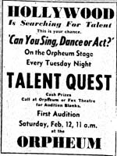
In January 1949 advertisements were placed in newspapers around the country about a “talent quest.” I didn’t find an ad or any article in a Salina Journal inviting contestants to sign up but I did not do a thorough search for any -- my limited time in the Salina library was better spent on finding articles on Nelson. Besides, I already had some ads from other cities. The one on the right is from Atchison, KS.
Here’s how the Moberly (Missouri) Monitor-Index and Democrat described the contest on January 19, 1949. Salina’s local contest must have been very similar. “A Coast-to-Coast ‘Talent Quest’ will start Monday, Jan. 31 at the Grand Theater [substitute with “Watson” in Salina's case] and will be held on the next four consecutive Monday nights. This 'Talent Quest' is part of a nationwide search to give professional recognition to unknown entertainers. It is open to both professional and amateurs, there is no age limit. There will be weekly cash prizes of $25. The winters from each weekly contest will compete in finals to be held at the Grand around the first of March. The winner of the final contest will be sent to Kirksville [substitute “Salina”] to complete in district finals. From there the winner will receive an expense paid trip to Kansas City [no substitution needed] for an appearance at the Tower Theater. The winner in Kansas City will receive an expense paid trip to Hollywood, Calif., to compete at the world-famed Grauman’s Chinese Theater. The final winners in Hollywood will compete for first prize of $1,000, second prize of $500 and other cash prizes as well as a movie screen test.”
The whole contest was conducted by National theaters which had 550 theaters in 20 states and was closely associated with the 20th Century Fox movie company. They had the highest executive(s) in common.

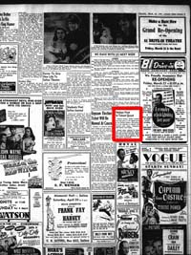
Local Contest. Salina’s Fox Watson theater was part of this chain and sponsored a local (and later regional) contest in this Quest. I found no mention in Salina Journals of the on-going contest until a tiny notice (inside the little red box, left) on page 3 of the March 19, 1949 Journal that Charles Nelson won the talent quest at the Watson on Friday, March 18. Second place winners were Rae McCreary (Salina) tied with Kenneth and Joan Smith (Salina tap dancers). Third place went to Roth Gatewood (Sylvan Grove), a marimbist. Nelson advances to the regional to complete with winners from Hays, Concordia, Clay Center and Lyons. But, in general, "ho-hum." If there were five preliminary local rounds in Salina, they must have been on Feb. 11, 18, 25, March 4, and 11, with the finals on Friday night March 18. I saw nothing in Salina Journals about contests on those dates. I suppose if the number of contestants was small, there may have been only the one, final round on March 18 but I bet there were multiple nights.
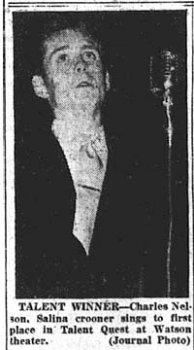
Meanwhile, winners were being selected in Kansas and around the nation. At the local contest in Hutchinson the first prize ($10) was won by a tap-dancing team, followed by an Al Jolson impersonator, a pianist, a vocalist, and a novelty actor.
At Emporia the contest was won by a trumpet player with a baton twirler taking second. These had beat out hopefuls who played the piano, tapped, and sang as a quartet.

Regional Contest. A collection of such local winners from Hays, Concordia, Clay Center, and Lyons came to Salina’s Fox Watson on Thursday, March 24 to determine a regional winner. Nelson again won. This time he got a front-page notice in the next day’s Journal. But the article was no longer than before except for a photo of him (right). At least the contest and Nelson's minimal attention had moved from page 3 to page 1. He was chosen the regional winner by audience applause and judges (not identified) as having “the best in talent and ability and stage presentation.”
Other regional contests in Kansas were held in Wichita, Lawrence, and Topeka. They would gather with winners from Missouri and Illinois.

Division Contest. The next step in the talent quest was to win a divisional contest in one of nine big cities. Nelson was in the Kansas City division on April 4, 1949 and won it! This earned another front page Journal story that was almost three times longer than the previous stories (no photo of Nelson). Here’s the text of the article:
“Salina’s Charles Nelson, 15 year old baritone, sang his way to victory in a divisional talent contest at Kansas City Friday night. He wins a free trip to Hollywood for screen tests. He will appear at Grauman’s theater there the week of April 18 and compete against other divisional champions from Denver, Milwaukee, Seattle, Los Angeles, San Francisco, Salt Lake City and other cities. His mother, Mrs. Vivian Cochrane Nelson, 705 West Iron, a former professional dancer and dance instructor, will make the trip with him. She has two younger sons, Gary, 13, and Mike, 6.
“Young Nelson’s singing won the title over seven other entertainment acts from Missouri, Kansas and Illinois. After winning out over other contestants in the local talent quest, Nelson won the district contest in Salina two weeks ago, entitling him to go to Kansas City.
“Young Nelson is a sophomore at Lincoln high school. His vocal instructor is Paul Ryberg, of the Salina high faculty.”
(Note: “Lincoln high school” sounds odd, but perhaps in those days sophomores went to Lincoln while juniors and seniors went to Washington. That’s just a guess.)
The Emporia Weekly Gazette of April 14 gave some details of the division competition even though their own local boy didn’t make the cut: “Winner at Kansas City was Charles Nelson, a 15-year-old Salina baritone singer who rated first with his solo, ‘Without a Song.’ Second place went to ‘Men of Song,’ a young men’s quartet from Kirksville, Mo.”

Final Contest. I couldn’t find a coherent, detailed account of just what went on in Hollywood but it was a multiple-day event at Grauman’s Chinese Theater and Nelson was a crowd favorite throughout. Here’s how the Journal described it in an April 20 article of unprecedented length on Nelson:
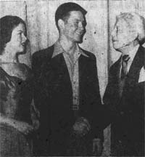
“How’d you like to hobnob with movie stars, appear on a television show, sing at Grauman’s Chinese theater in Hollywood and see movies in the making at the film capital? That’s what Charlie Nelson, sophomore singer from Salina high is doing." (In this photo from the April 21 Journal he's hobnobbing with Shirley Temple, who was only 21 and 5'2" herself, and Sid Grauman days before winning the contest.)
“He won a divisional talent contest at Kansas City, entitling him to a trip to Hollywood. He and his mother, Mrs. Vivian Cochrane Nelson, appear to be having the kind of time people dream about. The 15 year old baritone is making two appearances daily at Grauman’s. There’ll be three appearances Sunday (April 24), and the last one is important. Then the audience will select the national talent quest winner.
“How’s Charley doing in the final competition against other divisional winners from over the country? Well, Monday night (April 18) he stopped the show. He sang two numbers, threw a few kisses at the audience and made several bows. But the audience on its feet wouldn’t let him off the stage. He came back and sang another tune.
“A telephone conversation with Mrs. Nelson Tuesday (April 19) revealed her son had made two television broadcasts, and has more scheduled. His screen tests were set for Tuesday (April 19? before the contest was over?). Monday night (April 18) he had his picture taken with Mickey Rooney and Shirley Temple – an honor none of the other contestants could claim at that time.
“Mrs. Nelson said she didn’t know for sure when they’ll return to Salina. It depends largely upon the outcome of Sunday night’s final performance. They’re both a bit homesick, they say.”
On April 21 (Thursday) a Journal article said that the “Dope is Nelson may win” the finals Sunday night (24th); remember when “dope” meant inside information?
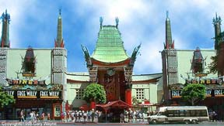
Adding to the confusing dates of events is this excerpt from the web site for the Grauman’s Chinese Theater:
Wednesday, April 20, 1949 @ 8:30 PM
"Talent Quest" Nationwide Finals
9 Big Acts
Eddie Bracken in Person
The Top Winners from 600 Theatres in 20 States
Manny Harmon and Full Stage Orchestra
Dick Haynes, Master of Ceremonies
Since Nelson won the contest on Sunday, April 24, the April 20 date must be when appearances on stage were started but may not have been part of the judging. Or maybe they were -- I can’t tell. “9 Big Acts” refers to the 9 finalists in the contest. The number 600 of theaters may have been rounded up from 550, but who’s counting?
Sure enough, HE WON! The Journal’s edition on Monday, April 25, spread the news in an article that needed two short columns (but no photo) for the telling:
“Charles Nelson, 15 year old baritone, Sunday night did what all Salina was hoping he’d do. He won first place in the finals of the national ‘Stars of Tomorrow’ talent quest in Hollywood.
“Young Nelson, sophomore at Lincoln high school, was one of the nine acts which performed before a packed audience (2100) at the renowned Grauman’s Chinese theater. Those nine regional talent quest winners had won recognition over some 15,000 contestants in 550 theaters from coast to coast.
“Besides the honor of being national champion, the Salinan was awarded $1,000 in cash, a $1,000 diamond ring, and a custom made watch. He’ll also be given a screen test by 20th Century Fox studios. This means the possibility of a screen career.
“The winners at Grauman’s were selected by audience applause and a panel of judges. The judges were Ivan Kahn, executive talent scout of 20th Century-Fox studios; Milton Lewis, executive talent scout for Paramount, and John Kingsley, president of the Hollywood chamber of commerce.
“Second place went to Gordon Leigh, 13, boy soprano from Seattle, Wash.; third place to Alfred Purcell, 13, concert pianist from Alhambra, Calif; and fourth to Albert Uhalde, baritone from San Francisco.
“Charley Nelson has been in the film capital for more than a week with mother, Mrs. Vivian Cochrane Nelson. He appeared each night last week at Grauman’s, and has also made television appearances.
“The singing sophomore’s grandparents are Mr. and Mrs. W. H. Cochrane, 705 West Iron. Mrs. Cochrane said Monday her daughter told her in a telephone conversation young Nelson was to appear this week on the Horace Heidt and Eddie Cantor radio shows.
“The Hollywood contest was conducted by National theaters under the sponsorship of Charles P. Skouras, president.
“Nelson won his initial chance on the stage of the Fox Watson theater in Salina. ‘We’re mighty happy we had a part in giving this fine Salina boy his chance’, said Earl Hilton, Fox city manager.”
The Spokane (Washington) Daily Chronicle on April 25 said that “Gordon Leigh, a 13-year-old soprano from Seattle, won second place and $500 plus a $500 diamond ring. Third place went to Alfred Purcell, also 13, a concert pianist from Alhambra, Calif., who received $250 cash plus a $250 diamond ring. Albert Uhalde, baritone from San Francisco, won fourth, which included $100 in cash and a $100 diamond ring. The other five finalists each receive $50 and a $100 watch in addition to the 10-day trip to Hollywood.” (Multiply all these cash amounts by about ten to get their values in today’s world.)
What would a $1,000 watch look like in 1949? Try to picture a $10,000 watch today (I suppose diamonds are involved.)
The contest was said to be open to those of all ages and professional entertainers were as welcome as amateurs. It seems odd that the top winners were all teenagers.

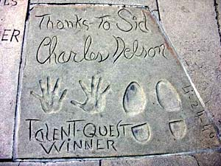
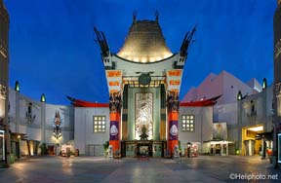

One of the prizes to the winner was to press your hands and feet in wet concrete in the forecourt of Grauman's Chinese Theater just in front of the entrance (photo on the right). Nelson and Richard Widmark both did the deed on April 24, the same day as the contest final. (I'd guess that Widmark's ceremony was earlier in the day of the contest.) Perhaps the finals were in the afternoon, leaving time to immediately step out into the concrete. I'm not clear on the sequence of events, but the important fact is that Nelson made the imprints and they are still there today. Here's a photo off the web of his slab (indeed showing the date of 4-24-1949). Some of his neighbors are Roy Rogers (and Trigger) from three days earlier, Jean Simmons, and Humphrey Bogart. Amazingly, this ceremony in concrete did not seem to make the Salina Journal! Photos abound through the years of movie stars on their knees showing their messy hands above their slabs, making good publicity for the theater. Wouldn't such a photo have been taken of Nelson and distributed widely for publicity? Wouldn't you think such a photo of Nelson would be on the front page of the Journal? I have no explanation.

The Career, Part One
What all happened during the rest of 1949 in the immediate aftermath of the contest is a bit sketchy to me but obviously many good things happened very quickly -- before returning to Salina to finish high school!
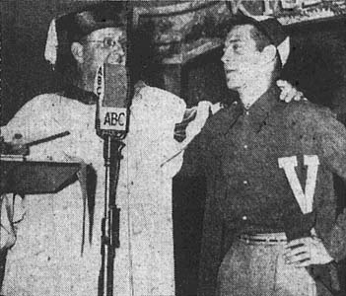
There must have been screen tests at 20th Century Fox before or after he won, if not both, but I don't find a clear record of this. Others in the entertainment world sought him out. This is from the April 27 Salina Journal: “Charles Nelson, Salina’s national talent quest winner, will be one of the ‘students’ on Kay Kyser’s ‘College of Fun and Knowledge’ broadcast from ABC Thursday (April 28). The 15 year old singing sophomore will show the ‘ole professor’ how his baritone vocalizing gained him first prize in the national finals at Grauman’s Chinese theater in Hollywood last Sunday. Nelson, a student at Lincoln high here, is still in Hollywood with his mother, Mrs. Vivian Nelson.” (Kay Kyser was a bandleader and radio personality; see http://en.wikipedia.org/wiki/Kay_Kyser.) Nelson is getting an honorary degree from Kyser during a broadcast in the photo to the right; I wonder what the "V" stands for, if anything.
The Register-Guard of Eugene, Oregon on May 29, 1949 reported that their second-place winner is back home while Nelson may appear with “Ken Murray’s famous ‘Blackouts of 1949’, or as a regular feature of the Edgar Bergen radio show.”
Ken Murray was an entertainer who put together variety shows under the name “Blackouts.” His 1949 version was being formed just as Nelson won the contest. Blackout in this context means “A short, comic vaudeville skit that ends with lights off.” http://en.wikipedia.org/wiki/Ken_Murray_%28entertainer%29)

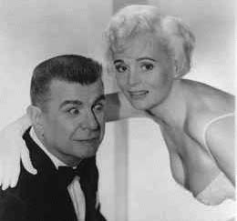
That's Murray in the photo on the left with his main attraction(s) in his series of "Blackout" productions, Marie Wilson. You might recall Wilson from her own TV show in the 1950s called "My Friend Irma." From what I read this photo typifies the caliber of humor used in skits of the "Blackout" -- not that there's anything wrong with that. And audiences were delighted, so there.
It seems that Marie was in the "Blackout 1949" Hollywood run right after the contest but stayed there to make movies instead of going to New York City for more "Blackout 1949" on Broadway. She'd been doing Blackouts since 1942. (She was replaced at $1,000 a week by a look-alike, 18-year-old Pat Williams. In 1955 Pat's attempts at becoming a movie star failed and she worked at the Sands in Las Vegas in a chorus line when Charles was also there, not that this is any more than a coincidence.) So Nelson would have been in the same Hollywood shows as Marie and then at the Sands with Pat, for whatever that's worth.
The Salina Journal seems devoid of Charles Nelson news for a few months until this note Sept. 13, 1949:
“Charles Nelson, Salina baritone who took Hollywood by storm with the Ken Murray Blackouts, seems to be doing the same thing now that the show has moved to New York.
“The Blackouts opened Sept. 6 (Tuesday) in New York and Mr. and Mrs. W. H. Cochrane, 705 West Iron, grandparents, have received glowing reports of young Nelson’s reception. Irving W. Cahn, critic, wrote of him, ‘The host, Charles Nelson, a 15 year old lad with a beautiful baritone voice, is a Metropolitan Opera company certainty if he wants that dubious honor.’
“The show is playing to packed houses, and is sold out for some time to come, Mrs. Vivian Nelson, mother of the singer says. Charles Nelson started to school in New York Tuesday. Last year he attended Salina high.”
I don’t know anything about Irving Cahn but I doubt that he knew anything about opera singing. Nevertheless, while in New York for the “Blackouts,” Nelson had some lessons with the immortal Metropolitan Opera baritone Robert Merrill and Enzio Pinza (have you see him in the movie version of "South Pacific"?). Those are two great singers so Nelson took good advantage of his time in New York City. But opera was not in his future.
The Ed Sullivan Show and Blackouts originated in New York City and why wouldn't Ed book a 15 year old with Nelson's credentials? But I could find no record that Nelson was ever on that show; however, the surviving record of acts on Ed's shows (yes, such things are on the web) is mostly blank for 1949, so who knows? He did do TV shows with Murray for sure.
Here are two pages of the opening night program of "Blackouts 1949" four and a half months after the Talent Quest finals. The front page (left) lists Nelson among the performers. Page 8 (right) puts him near the end of Act I right after D'Vaughn Pershing (a piano and clarinet player) and just before Burton's Birds (a trained bird act). (Yes, such things are on the web.)

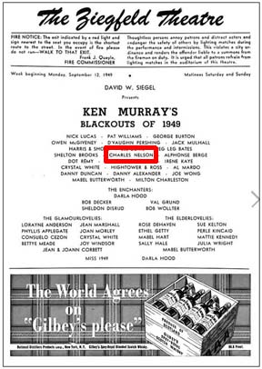 | 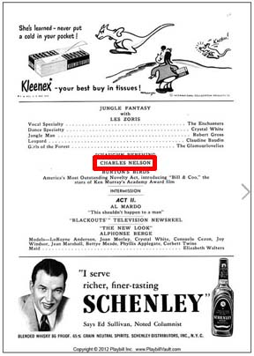

“Blackouts 1949” had 51 performances over 39 days and Nelson apparently was in them all. His mother was with him in New York and he attended some unnamed school at the same time.
Nelson drew further national attention in a newspaper column by Sheila John Daly who specialized on reporting teenagers’ activities and interests. She promoted Nelson as a role model for other teens. Here’s much of her column as found in the Berkeley Daily Gazette of November 16, 1949. It may have some minor errors or exaggerations but the gist of it seems right and she gives some details I didn’t find any place else (probably from a rightfully proud Mrs. Nelson).
“For the first 14 years of his life, Charles was aiming toward a career in professional athletics. He learned to swim at 3, placed first in every state swimming meet in which he participated (he recently out-swam an Olympic team member in an informal contest), pitched on the American Legion baseball team which won the Kansas state championship and played a hot game of basketball with the high school team that came within one point of winning the state championship. But on the side, Charles also was a talented singer who appeared regularly at club meetings and with church choirs in his home town, and played the lead in an assortment of high school operettas. His voice began changing at 11, and he was silent for a year, but when he began to sing again, listeners recognized a real talent.
“Came the beginning of 1949 and Charles, at the urging of his mother, a former ballet dancer, entered the preliminary contest in a national talent quest sponsored by a chain of theaters. Six contests and three months later, Charles appeared on the stage of Grauman's Chinese theater in Hollywood, to compete against the 10 [8] other finalists culled from more than 40,000 [15,000] entries from all over the country. After performances on seven [5?] consecutive nights, the judges (who included talent scouts from major motion picture studios and top Hollywood stars) named Charles the grand prize winner. They presented him with $1000 in cash, a $1000 diamond ring (which he gave his mother for Mother's day) and a diamond studded wrist-watch, as well as a chance of a screen test and the opportunity to immortalize his footsteps in cement at Grauman's.”

Homecoming
After “Blackouts 1949” closed on Oct. 15, 1949, Nelson returned to Salina to finish high school [doesn't that sound weird?] while also keeping his career in singing alive. (He had only missed the last month and a half of the sophomore year and the first month and a half of is senior year.) His first public act in Salina was to give a concert for the home folks. The Salina Journal of Nov. 12, 1949 described it:
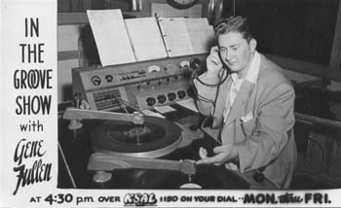
“Charles Nelson, back in Salina high school after a sensational engagement with the Ken Murray Blackouts, will make his first real bow to the home town Tuesday night (Nov. 15) in Memorial hall. He is being presented by the Isis Temple Shrine.
“His first real concert after much singing in recent months, young Nelson will not be alone on the program. He will have the assistance of Al Thompson, pianist; the Elks club quartet; Mary Joyce Dandurand, dancer; Gene Fullen and his band [remember this KSAL announcer? and his pal Groovey? Photo from Joan (Stermer) Linam)]; and the high school chorus, conducted by Paul Ryberg.
“With the Gene Fullen band Nelson will sing ‘You’re Breaking My Heart’, ‘That Lucky Old Sun’ and ‘So In Love.’ With Thompson at the piano he will be heard in ‘Rain on the River’, ‘Without A Song’, and ‘Shadrack’. And with the high school chorus he will do ‘I Dream of You’, and ‘Ballad For Africans’. The chorus alone will sing ‘All the things You Are.’
“Of the Salina singer, who was a sensation with the Blackouts on the west coast and in New York, the Sunday New York News said: ‘He is a young fellow who knows where he’s going – and he’s wasting no time getting there. At 15 he was a featured performer in Ken Murray’s ‘Blackouts’ recently playing on Broadway, and he has a future as bright as the footlights before which he performed.’
“This time last year Charles was just another sophomore at Salina, Kan. High school, having achieved fame locally as a quarterback on the high school football team. Now he is a lad to be reckoned with as a national figure in show business. He has movie offers to be considered and more than $2000 worth of prizes won in a national talent contest.
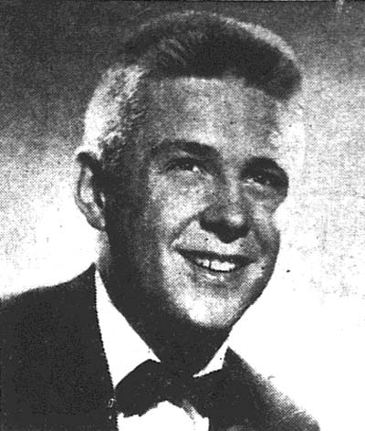
“After Ken Murray heard Charles sing on Monday [April 25?], he hired him on Tuesday and put him on the show Wednesday. He has signed a recording contract with Capital records and will appear in an important spot on the Ken Murray TV show.
“’I’ve always thought that if you had talent the worst thing in the world was to hide it,’ says Charles – and as things are going now most of the country will get a chance to see the terrific talent of young Charles Nelson.”
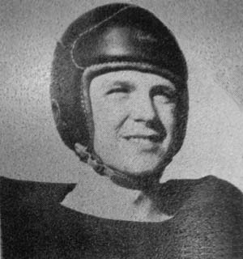
Too bad video and even audio recording were so difficult and therefore rare in 1949.
This portrait (left, from Hollywood or New York, I bet) ran in the Salina Journal to promote the concert. The caption reads: "He went west, then he went east, and now Charles Nelson is back from the glamor lanes to sing for the home town Monday night [Tuesday night?] in Memorial hall."
Remember this was still 1949 and he was a first-semester Junior in high school.

I found almost nothing about Nelson for the year 1950. The Journal was silent and the SHS Trail is missing from the library. It seems safe to assume he was active in sports and stage productions. A 1951 Journal alludes to his victory in yet another contest in 1950, this time in Salina’s Memorial Hall.
Horace Heidt was a band leader and radio personality who also ran talent contests (http://en.wikipedia.org/wiki/Horace_Heidt ). His organized local one-night contests around the country. During a Heidt contest in Salina in 1950 Charles Nelson won again; his reward was to sing on a Heidt radio show broadcast from Denver. Heidt returned to Salina for another contest on March 2, 1951, but apparently previous winners, like Nelson, were excluded.
In 1951 the Trail shows that high school senior Nelson had been the quarterback on the football team, a guard on the basketball team, had the male lead in the school musical (Gilbert and Sullivan’s operetta “Ruddigore”, Feb. 12 and 13), and was in the dramatic club’s play (“I Remember Mama,” April 11, 12, and 14 in the Washington high school auditorium, Jack Kelly director).
He was a popular choice to sing at weddings in 1951 even before high school graduation that Spring. Whether these were favors for friends or as a professional I can’t tell.
Perhaps one appearance in Salina March 28, 1951 was as a professional: “Memorial hall was crowded Wednesday night for the Elks’ club dance at which Jan Garber and his orchestra played. As a special and unheralded attraction, Charles Nelson, Salina’s own baritone, sang three numbers with the band.” Or perhaps he sang on this occasion because he enjoyed singing, or as a favor for someone in the Elk’s club.
Bethany College in Lindsborg lettermen’s club (The B-Club) had an annual variety show that charged admission (75 cents for adults, for example). Among the attractions on May 18, 1951 was Charles Nelson, “Salina high school senior….”
Finally, in May 1951 it was time to graduate from high school and begin a serious singing career.

The Career, Part Two
I can’t say just what Nelson did the first couple of years after high school graduation in May, 1951. A 1956 Salina Journal article said he went to Wichita University for a semester (to study singing?) before going back to California, but that's all I've found. Until 1953 the Salina Journal was silent on Nelson but clearly by 1953 he had a singing career going. His timing was unfortunate because the era of crooners (Bing Crosby, Frank Sinatra, Perry Como, Nat King Cole, Jane Morgan, and others) was soon to be eclipsed for the younger crowd by rock and rollers Bill Haley (1954), Elvis Presley (1956), and so on.
There was a fairly new haven, however. Las Vegas, Nevada was now finding success with its casinos and stage entertainment. Rockers like Elvis became Las Vegas headliners eventually, but in the 1950s the shows must have been aimed at the generation spending the most money, and these weren’t teenagers. So a smooth, lyrical voice like Nelson’s could, and did, find a welcoming audience in the desert. Plus, there were records to make and sell.
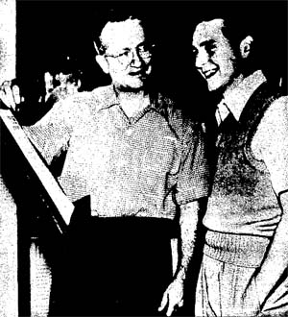
In January, 1953 the caption to this photo read “Salina’s Charles Nelson recently signed a 5-year contract with Columbia Recording company in Hollywood. He has recorded several popular songs which are rapidly becoming hits. Nelson is also testing for a film musical role.” He was matched with the Paul Weston orchestra to make records. I reckon that Nelson was all of 19 at this time.
Amazingly, I have two of those 60-year-old 78 rpm records thanks to a dealer in old records in Nashville, TN. The first record of this collaboration came out in 1952, so maybe this photo was released to help promote their record. The copy I own was for use by radio stations only and has a fidelity far above my expectations for a 78. In fact, it sounds like it was hardly, if ever, played. That is great for us today, but bad news in 1952 for the artist wanting to be heard often on the radio.
The other disk I have was called his second record in the March 30, 1953 Salina Journal and was released on March 16, 1953. My copy has been played in someone's home enough in the past to gain some minor noise. But I'd say it's still in good condition.
If those are indeed Nelson's first two records, there's quite a time gap between them. Something changed during this gap because the 1952 record label reads “Paul Weston and his Orchestra, featuring Charles Nelson,” while on the 1953 record we find “Charles Nelson with Paul Weston and his Orchestra.” Whatever the billing sequence, Nelson was obviously the star on both records with the orchestra as back up.
That 1953 Journal article also said "Nelson was graduated from Salina high school in 1951 and has been with the Paul Weston orchestra for several months. This is his second record. He recently appeared on the Jo Stafford, Edger Bergen, Peggy Lee, and Art Linkletter shows, as well as with the Robert Armbruster Hollywood Symphony orchestra.”

AND NOW, you can hear Charles Nelson sing four songs, 60 years after the fact. I don't have a 78 rpm player but a nearby patient friend does. The records are in good shape so the quality of the sound depends on the speakers you have. Tiny speakers built into a computer or tablet give a tiny sound that won't reproduce the smooth, powerful voice of Charles Nelson. Good earphones will do a great job. The songs are stored at http://salina57.com/SHS57/Salina%20Links.htm; go there and scroll down to the list of four songs.
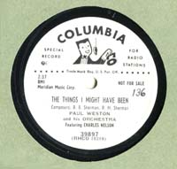 | Click on this label to hear "The Things I Might Have Been," released in 1952. The white label indicates it was for radio stations, not for sale. It's quite a gentle, sentimental song beautifully sung by Nelson.  The composers were the Sherman brothers who later wrote music for Mary Poppins, Winnie the Pooh, Chitty Chitty Bang Bang, It's A Small World (After All)," and much more. http://en.wikipedia.org/wiki/Robert_B._Sherman Others have recorded it over the years but I wouldn't listen to anyone else's rendition except Johnny Mathis' (1975).
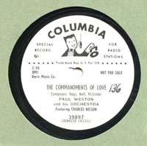 | The flip-side has "The Commandments of Love." You get some sense of the power of Nelson's voice during this song, but nothing like hearing him in person.  The composers were Morton Weinstein a.k.a. Morton Neff, John Nagy & Lucky Millinder (Lucius Leroy Millinder). I can't find a year of composition.
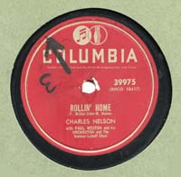 | "Rollin' Home" is one side of a record on sale in 1953. The composers were F. Miler, Dehr and B. Hawes. On the web I found lots of references to a different, newer song of the same name, but nothing was found about this version sung by Nelson.  The pace is quite snappy. Nelson is backed up by the Norman Luboff Choir, a leading choral group in the 1950s through 1970s.
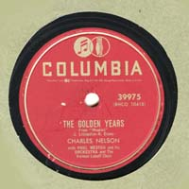 | This just might be my favorite of the four. "The Golden Years" is not just a sentimental, sweet song, but it's in WALTZ time!! That's not only a rare tempo in 20th century popular music but in retrospect we know that Elvis and "Heartbreak Hotel" was only three years away! What a jolt to the ears to jump from a crooner's waltz to Elvis' rock.  The label credits J. Livingston and R. Evans and says it is from "Houdini." Actually, it's part of the "Poet and Peasant Overture" written in 1846 by the then-Austrian (now-Croatian) Franz von Suppe. This part of the overture was "borrowed" for the 1953 movie, "Houdini," starring Tony Curtis and Janet Leigh (an hour into the movie during a dance scene), as well as on many, many other occasions throughout many decades. I assume Livingston and Evans added the lyrics heard here.  A good recording of the whole 9.5 minute overture is available to hear at http://www.youtube.com/watch?v=c3_aM_s0R1U . The waltz starts 5:15 minutes into it (and repeats at the 7:05 minute mark). If you'd like to read the sheet music as you listen to a piano arrangement, go to http://www.youtube.com/watch?v=mF508Uca8mc ; the waltz begins at the 5:27 minute mark in this case.

In 1952 three types of records were in play. Half the records bought were on 78 rpm, 10” disks, like those above. A third of the sales was on the new 45 rpm, 7” records. Only 17% were on the 33 1/3 rpm 12” LPs (Long Playing) aimed at albums and lengthy classical music. Some (many?) recordings were sold as both 78 and 45 records for several years in the 1950s until 45s became dominant for popular "singles." So you just might be able to find some of these songs above also on 45 records. By 1962 almost no 78 rpm records were being bought.
The quote a bit before the recordings states that Nelson was busy making appearances on many broadcast shows as he started to make recordings. I didn't find a clear statement what else he was doing in 1953 and on into 1954, but a reference (given just below) makes this seem to be when he started working at Las Vegas.

The Salina Journal never would have followed Nelson’s career had it not been for his proud mother sending in a note now and then to describe her son’s activities. These notes typically appeared in the “Cuff Stuff” social column as one paragraph among many.
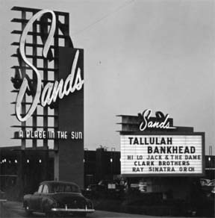
One such paragraph tells us that in Feb. 1955 Nelson was working at the Sands Hotel in Las Vegas because Dr. and Mrs. Osborn saw his name on the marquee when a TV camera panned past it during an Edward R. Murrow TV show on Las Vegas. (The year is about right for the photo on the left, but the marquee didn't have the Nelson name at the time.)
Another “Cuff Stuff” note in August 1955 reported that “Charles Nelson, son of Mrs. Vivian C. Nelson, is now starring in a night club performance in Las Vegas, Nev. He is featured with Tallulah Bankhead in a production of the Ziegfeld Follies. Nelson has been working on productions for two years at The Sands in Las Vegas. Lyrics and music for the show are by two big Hollywood names, Bob Hilliard and Milton De Lugg.”
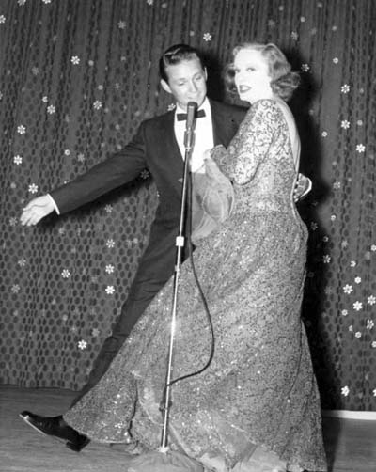
Tallulah Bankhead (1902-1968) was an actress on stage and in film, but most famous for her libertine life style (I’ll let you read about that elsewhere). The Sands gambled on her doing a successful one-woman show (at $20,000 a week in the early 1950s!) and won. She was a smash hit for a year or two before the Ziegfeld show with Nelson. She gave entertaining monologues (racy, I’m sure -- Marie Wilson was a tease, Tallulah was the real deal), singing, and reading poems. I don’t know what the Ziegfeld show was like or how many were in it. The original Ziegfeld Follies in the early 1900s were collections of variety acts with lots of pretty dancers.
A web search for Bankhead led to this photo of her at the Sands with an unidentified good-looking young man behind Bankhead -- I'll bet he's Charles Nelson. It's OK -- he was over 21, barely.
Another Nelson record was released in January 1956. His mother had the Journal tell Salinans how to hear it right away. “The newest record, ‘Slap Happy,’ by Charles Nelson, Salina tenor [no longer a baritone], was to be played during Peter Potter’s ‘Juke Box Jury’ from Hollywood over the CBS radio stations Saturday at midnight. Nelson has left Las Vegas where he was a night club entertainer. He is now making records in Hollywood. He and his wife are expected in Salina next week.”
Yes, Nelson had married Becky Steiner two years earlier. A March 9, 1956 Journal note explains that “Nelson married Becky Steiner in 1954. She had played a nurse on a Bob Cummings TV show (but left no mark on the web). They met at the Sands in Las Vegas. They now live in Hollywood. Nelson has not been home to Salina in four years but is coming.” (Alas, this marriage was not to last much longer.)
The screen test at 20th Century Fox in 1949 doesn’t seem to have resulted in any career in the movies, yet in July 1956 a Fox Watson ad for the movie “Toy Tiger” with Jeff Chandler and Laraine Day included a small box at the bottom saying “Salina’s Own Charles Nelson with The Mills Brothers in a New Musical Short.” The 1956 movie short was “The Mills Brothers on Parade,” where Chuck Nelson sings his “Slap Leather.” [A couple of web sites that show old stuff appear, at first, to offer the chance to see the short, but in fact only have information about the production: http://www.imdb.com/title/tt1189087/?ref_=nm_flmg_slf_2 and http://www.tubeplus.me/player/558973/The_Mills_Brothers_on_Parade/ .]

A Home Visit
Interview. Nelson came back to Salina for Christmas 1956, his first return since high school graduation. He was interviewed by the Journal which made it into a front page story, complete with this photo with his mother. (Quite a change from the 1949 tiny articles.) Here are some gleaming from that article, including a hint at what he did right after graduation.
The Journal says he is 23 and it is late December 1956, so he was indeed born in 1933.
His first public singing was at age 9 at a band concert in a Salina park. He recently completed an engagement at the Sands Hotel in Las Vegas on the same bill as Jerry Lewis. On Jan. 18 he starts an engagement at the Riviera Hotel in Las Vegas. Then he has spots on the Peter Lind Hays – Mary Healy show and the Arthur Godfrey show.
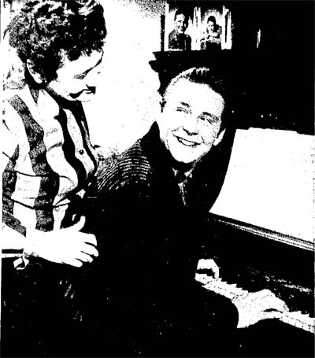
“I went to New York with Ken Murray and did my first television show there.” He returned home after a year and a half [five months, I calculate] with Murray and finished school, graduating from Salina High in 1951. “Paul Ryberg was one of the best vocal coaches I’ve ever worked with.” Nelson studied a semester at Wichita University before going to California again. He signed a contract with Columbia records and recorded with Paul Weston and his orchestra.
“My first good record was ‘Slap Leather’ and it was nationally known. It was sort of a Frankie Laine (remember "Rawhide"?) type song.”
Nelson has appeared on the Peggy Lee television show and on the Edgar Bergen and Charlie McCarthy show. Nelson is now with the Era recording company and has a new release, “Callin’ My Love” coming out at the end of January [1957].
“Life is quite different in Las Vegas. Here you go to bed at 9:30 or 10 pm. Out there you get to bed at 6 or 7 in the morning. The last show is over about 2:30 or 3 am.”
“Rehearsals take eight hours a day. We change shows every four weeks and have two weeks between shows for rehearsals.”
As a fellow entertainer, Nelson respects Frank Sinatra. “He’s one of the finest actors in show business. He’s temperamental but warm.”
Of Jerry Lewis, who appeared with him at the Sands, Nelson said “Jerry is a fine entertainer and person. He’s very natural on the stage. And he can be just as serious as he is funny.”
If he'd been on the Ed Sullivan show, this would have been a perfect time to mention it.
Nelson will sing “The Twenty-Third Psalm” at the First Presbyterian Church Sunday.
Nelson stayed in Salina through January, 1957 and did some singing for the home folks.

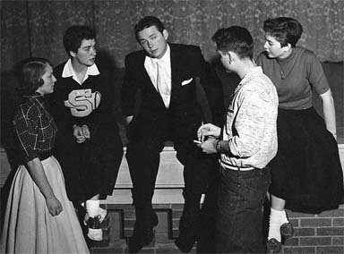
SHS Assembly. “Salina high school students stood 17 deep Friday morning [January 11, 1957] to secure autographs of an SHS graduate, Charles Nelson. Nelson, a singer who has appeared in radio and television shows, gave a 45-minute concert at the school. His accompanist was Mrs. Paul Ryberg. He was interviewed by Jack Kelly, head of the dramatics department.”
So now we know where and when Ginny got his autograph, shown on the next page! (How does this signature, written in haste, compare to the one in concrete, written for eternity or 100 years, whichever comes first?) The photo on the next page shows Nelson surrounded by autograph seekers.

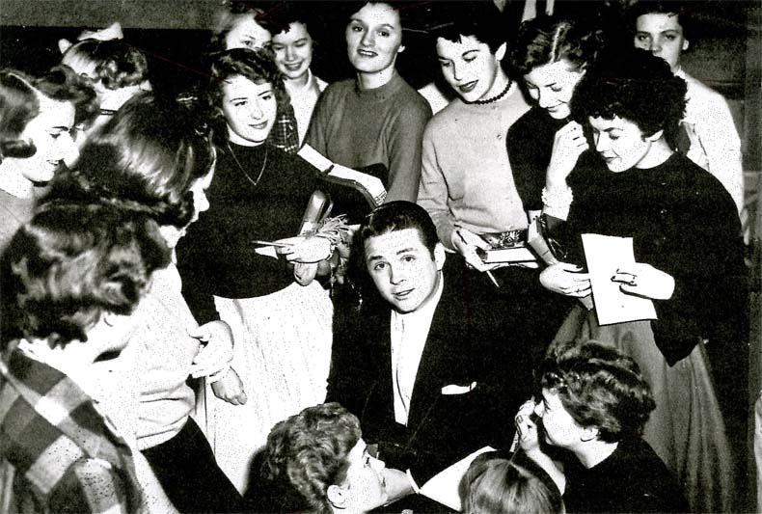 | 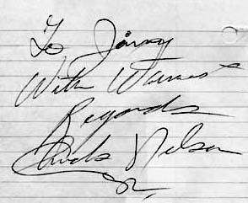

Betty has an aftermath story to this photo. A small group in Salina of the Class of '51 were getting together with Charlie that evening and recently divorced Charlie asked Betty to accompany him since everyone else were in couples. Betty had to convince her parents, but she was allowed to go after the basketball game...still in her cheerleader's uniform. After the get-together Betty went on to Ardyn's slumber party.
Performances. Continuing with the interrupted Journal article, “Charles Nelson, singer now visiting friends and relatives in Salina, will sing and discuss his career at the Kiwanis Club meeting at 12:10 pm Tuesday [Jan. 22] at the Hotel Lamer.”
“The Salina high school a capella choir and Charles Nelson, radio and television performer, will combine to give a concert in SHS auditorium Monday [Jan. 21]. The 1 1/2 hour program begins at 8. The admission charge will be $1. The money will be divided between the choir and the soloist. Nelson has asked that his share be given to the cancer fund. The choir will use its share to help pay expenses of its tour Wednesday to five nearby high schools.”
The Journal on the next day said this: “About 1000 persons attended the concert presented by the Salina high school a cappella choir and Charles Nelson, radio and television performer, Monday night. The choir opened the program by singing several numbers. Nelson presented a variety of popular songs, ballads and two operatic selections. The concert closed with Nelson singing the solos with the choir numbers.”
As 1956 closed, Elvis was well on his way to a total re-make of the popular music scene. Johnny Mathis started making hit recordings in 1956 and kept the traditional style from being drowned out entirely by the encroaching cacophony (noise).

The Career, Part Two Continues
Performances. Mrs. Nelson continued to keep everyone informed of her son’s growing list of appearances. “Charles Nelson, former Salinan, now a professional singer, will appear on the Lawrence Welk show Monday (June 3, 1957) at 7:30 pm, Channel 10.” Web sites report that he was also on the May 22, 1958 Episode #3.37 of the Lawrence Welk show.
In the August 14, 1957 Salina Journal we get more caught up: “Charles Nelson, former Salinan who has made a name for himself as a singer, will be seen on Arthur Godfrey’s television program the week of Sept. 9. Nelson appeared as Jose, the baritone lead in the musical spectacle, ‘Maria,’ presented last weekend at the annual County Bowl Fiesta, Santa Barbara, Calif. The title role was portrayed by Clara Ray. The story narration was given by John Carradine, as Col. Jonathan D. Stevenson. Nelson’s other appearances have included Ken Murray’s ‘Blackouts’ on Broadway, the Lawrence Welk and Bob Crosby TV show and at the Sands and Riviera hotels in Las Vegas. He also has made several records including ‘Song of the Saddle’ and ‘Green, Green Mountain.’” [A web search didn’t find anything about these.]
Godfrey Flap. His appearance on the Arthur Godfrey show created a brief flurry (good-humored, I hope). The Sept. 12, 1957 Journal explained: “Charles Nelson, singer who was reared in Salina, has been ‘spanked’ in a nice way by the Salina Chamber of Commerce. Nelson, appearing this week on the Arthur Godfrey show, announced via the TV waves that he ‘came from a small town in Kansas.’ John Cranor, manager of the C of C, immediately fired back a telegram to master of ceremonies Peter Lind Hayes in which he declared Salina is by no means a small town, that it has a population of about 35,000 and is looking for new industries. Hayes substitutes for Godfrey on the show from time to time. “
A few days later Nelson was given some relief: “Letters To The Editor: Our Pride And Joy. Sir: On the front page of Thursday’s Salina Journal, our Salina boy, our pride and joy, Charles Nelson, got a ‘Spanking’ because of the remark: ‘Salina was a small town in Kansas,’ over TV on the Arthur Godfrey Show. In my opinion, Salina has been very small – small in his behalf. I think congratulations are in order for the lad, instead of the ‘Spanking’ he got. – ESTHER MEIER, 710 W. Elm.”

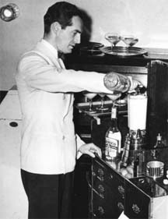
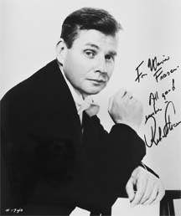
With Fred Waring. Late in 1957 we find the first reference to Nelson having joined the well-regarded, high-class choral director (and inventor of the food blender) Fred Waring (1900-1984) and his Pennsylvanians. That's Fred on the left with an early model of his blender. Nelson was not just a member of the choral but a soloist with the choral. An example of the Waring’s eye for talent was his hiring of a young Robert Shaw (right) in 1937 to train his singers. Shaw went on to a choral music career even more illustrious than that of Waring, culminating as director of the Atlanta Symphony Orchestra (1967- 1988). Unfortunately, Shaw had left Waring before Charles Nelson joined.
Selecting Charles Nelson as a soloist in his group was recognition of Nelson's talent because Waring had the highest standards. The Waring group went on many tours, seemingly not having a home base. Nelson was on one tour that included Hays, KS. “Fred Waring and his Pennsylvanians will present their new production, ‘Hi-Fi Holiday’ Nov. 26, 1957 at 8 pm in Sheridan coliseum at Fort Hays State college. Familiar stars appearing in the show will be Poley McClintock, Frank Davis and Leonard Kranendonk. New faces are those of Norma Douglas, singing comedienne, Fred Waring Jr., and Salina’s Charles Nelson. The show is billed as a ‘musical theater pageant.’”
A partial description of the show was in the Journal of November 22, 1957 thanks to some traveling Salinans: “Wednesday was something like ‘old home week’ in Tucson, Ariz., for Mr. and Mrs. B. R. Becker [no relation of Sheri’s], 1013 Court Place. The Beckers, on vacation in Arizona and California, attended a performance by Fred Waring and his Pennsylvanians and talked with Charles Nelson, native Salinan who is a member of Warring’s group. Nelson sang several solo numbers, Mrs. Becker said, and ‘Chuck’ and his wife, the former Angelo Marlo, sang ‘Easter Parade’ as a feature of the show. The show's theme is ‘Hi-Fi Holiday.’ The Waring show will be at Hays Nov. 26. Wrote Mrs. Becker: ‘We are sure everyone will be as proud of Chuck Nelson as we were.’”
So now we learn that Nelson had a new wife late in 1957, another soloist with the Waring ensemble. Unfortunately, I can't find a photo or anything else on the web about Angelo Marlo (spelled "Angela Marla" in a newspaper article on a Waring show). The marriage led to this birth announcement in the Feb. 11, 1958 Journal: “Mr. and Mrs. Charles Nelson, New York City, announce the birth Saturday of a daughter, Lauri Ann. Mr. Nelson, formerly of Salina, is the son of Mrs. Vivian Nelson, 705 W. Iron, and Harry Nelson, 540 S. 12th. Material grandparents are Mr. and Mrs. Joseph Catalano, Los Angeles, Calif. Mr. and Mrs. W. H. Cochrane, 705 W. Iron, are the paternal great-grandparents.”
Arthur Godfrey did not suffer gladly those he considered fools (remember the Julius La Rosa flap in 1953?), so it's a good sign that Nelson was welcomed to return to the show the week of March 24, 1958: “Chuck Nelson, Salina singer, will appear on Arthur Godfrey’s TV program all this week, he has informed his mother, Mrs. Vivian Nelson, 705 W. Iron. The Godfrey program is at 9:30 am on Channel 12. Nelson and his wife have just returned from a tour with Fred Waring’s orchestra and chorus.”
Appearances with Waring continued: “Chuck Nelson will appear as soloist with Fred Waring and his Pennsylvanians Nov. 6, 1958 at the Municipal Auditorium, Kansas City, Mo. His wife, a member of the singing group, will also appear.” This show was close enough to home for his relatives to attend: “Mrs. Vivian Nelson and Michael, and Mr. and Mrs. W. H. Cochrane, 705 W. Iron, attended the show presented by the Fred Waring and his Pennsylvanians at Kansas City. Mrs. Nelson’s son and daughter-in-law, Mr. and Mrs. Chuck Nelson were featured. They sang two selections apiece as soloists and teamed to sing ‘Easter parade.’ [I'd sure like to hear that.] At the end of the tour Mr. and Mrs. Nelson will return to the Sahara Hotel, Las Vegas, Nev., for appearances from Dec. 2 to the 22nd.”
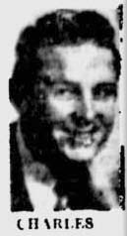
Before Nelson’s return to Las Vegas, the Waring show moved on to Wichita for a benefit concert: “Chuck Nelson, former Salinan, and his wife will be featured vocalists for Fred Waring and his Pennsylvanians’ benefit show Tuesday evening in Wichita. The show will be at the Moose Home, formerly the Trig Ballroom. Proceeds will go to the Institute of Logopedics, Wichita. The group is on tour and will be in Denver and Las Vegas following its Wichita appearance.” The Institute of Logopedics still exists in Wichita serving young children with severe speech defects (and possibly more).
I presume Nelson’s Las Vegas appearances were between Waring tours because in March of 1959 he is back with Waring in Daytona Beach, FL. The promotion for a Waring concert in the local newspaper even has his photo (very blurry in this reproduction on the right).
A 1960 Nevada State Journal has a nice article on the Fred Waring show coming to Tahoe, “Stereo Festival” (progressing from the 1957 “Hi-Fi Holiday” show). The group was in Tahoe for two weeks, giving two shows each day (three on Saturday nights). Among the female vocalists was Angela Marla. Chuck Nelson was one of the men and he sang “Mack The Knife,” and a crowd pleasing “Granada.” THAT would have wonderful to hear!
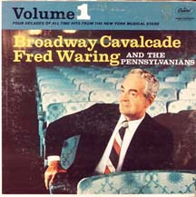
You can hear 30-second snippets of “Dancing in the Dark” and “Dance Only With Me” with Chuck Nelson soloist in the Fred Waring recording “Broadway Cavalcade, Vol. 1” at http://www.amazon.com/Broadway-Cavalcade-Fred-Waring-Pennsylvanians/dp/B004M8NV9I, bands 8 and 11. Rather frustratingly, “Without A Song” is on the same album but it’s not sung by Nelson (although I have to admit the bass singing it, Frank Davis http://www.youtube.com/watch?v=kWFChMmxERI is darn good, band 2).
Fred Waring had a TV show from 1949-1952 and some of them are on YouTube.com, but this was too early to include Nelson. I think I remember seeing Waring and his group on TV years later than 1952, but I guess these were isolated appearances. Might I ever have seen and heard Charles Nelson on TV and didn't realize it?

The Charles Nelson story as I can find it concludes abruptly about 1960, still early in his life -- news about him in the Salina Journals and the web dries up. Notes in the Salina Journal on the Nelson career stopped by 1959. A possible reason I've run into for this is too speculative to give here. At this point he was a mere 27 years of age so there is much more to the tale, could it be entirely known.

Epilog
Barbara (St. Clair) Pickering knew the Nelson family and recently called Gary Nelson (now in Louisville, KY) for more information. Gary said his mother worked as a salesperson at Shilling until 1966 when they shut down and then had a similar job at Ft. Riley. Vivian Nelson remarried and became Vivian Rathbone in the late 1960s. They were living in a trailer home at 2208 Meadowlark Lane of Salina on June 30, 1978 when she fell asleep in a chair and died in a fast-burning fire from a lit cigarette, Gary said (and as told in the July 2, 1978 Journal).
The SHS Class of ’51 has had reunions every five years. Announcements of them in the Journal included lists of those they hadn’t been able to contact. The name “Charles Nelson” was never in such a list until the May 29, 2006 Salina Journal where the class’ 55-year reunion was announced. That clue was filled in by Gary.
Gary told Barbara that Charles died about 10 years ago from a massive heart attack in southern California. I found "Charles W. Nelson" in the Social Security Death Index whose social security number (515-26-8655) was issued in Kansas, and Gary said Charles' middle initial was indeed "W". The Social Security Death Index says Charles was born Sept. 21, 1933 and died Jan. 6, 2003 in Costa Mesa, Orange County, CA (ZIP 92627). From Gary, the Social Security Death Index, and a brief California newspaper announcement, I take the deaths bracketing the life of Charles Nelson’s life to be as given.

