Jerry Just
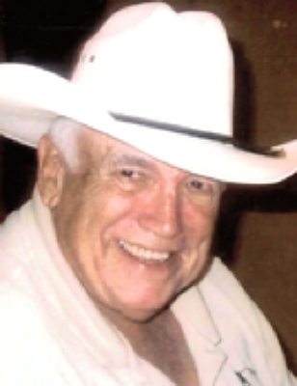

Dr. Jerry “Doc” Just, Jr., D.V.M., 80, of Pawnee City, Nebraska passed away on Sunday, March 15, 2020 in Pawnee City. He was born on July 17, 1939 in Salina, Kansas, to Melville L. and Beatrice (Hanley) Just, Sr.
At the age of 14, Jerry knew he wanted to grow up to become a veterinarian. He always had a great passion for the healing of animals. After graduating from Salina High School he attended Kansas State University in Manhattan, Kansas. After three years of pre-vet studies and being accepted into vet school, Jerry decided he could ask his high school sweetheart to marry him. On September 3, 1960 Jerry was united in marriage to Susan Bell at Peace Lutheran Church in New Cambria, Kansas.
Later that same September, Jerry started his last four years of study in the College of Veterinary Medicine. He graduated in 1964 with a degree of Doctor of Veterinary Medicine. After graduation, Doc took his young bride Susan and two small children, son Todd and daughter Tracy to Guymon, OK, then to Ottawa, KS and to Pawnee City, NE, making this their home. Doc loved every aspect of veterinary medicine. He never grew tired of the treatment of the animals nor the enjoyment he received in the friendships he had with his clients. He took great pride especially in his surgery. Each stitch had to be placed just exact and precisely tied off. It was definitely a labor of love and a work of art when he finished surgeries.
Doc took great pleasure being involved in or being a spectator at all activities that his children took part in. In later years he followed his grandchildren in all of their activities. He especially had fun with all of his family boating, hunting, fishing, water and snow skiing and all family gatherings to celebrate life together. Doc enjoyed visiting with everyone he met up with. He loved people.
Left to cherish Doc’s memories of never meeting stranger and always telling stories are his wife Susan, son Todd (special friend Susan Horton) of Overland Park, KS, daughter, Tracy (husband Doc) Doerr of Verdon, NE, grandsons, Phillip, Justin and Peyton Doerr, Doc’s two sisters, Marilyn (husband Joseph) Waddington of Waxhaw, NC and Carole (husband Bill) Batts of Wilson, NC, brother-in-law and sister-in-law Philip and Dixie Bell of Shawnee Mission, KS, and many nieces and nephews.
Doc was preceded in death by his parents, Melville L. and Beatrice Just, sister Jody and brother-in-law Jack Blankenship.
Services 10:30 a.m., Saturday, March 21, 2020 at Zion Lutheran Church, Pawnee City, Nebraska. Officiating Reverend Tim Llewellyn. Visitation on Friday, March 20, 2020 from 9:00 a.m. to 8:00 p.m., with family greeting friends from 6-8 p.m. at Wherry Mortuary, 919 G Street, Pawnee City, Nebraska. Interment at the Pawnee City Cemetery. Memorials in lieu of flowers to Pawnee County Medical Foundation for Emergency Medical Services or Zion Lutheran Church, Pawnee City, Nebraska. Online condolences may be left at www.wherrymortuary.com.
Per the recommendation of Governor Pete Ricketts and the Nebraska Funeral Directors Association due to the COVID-19 virus, the funeral home will abide by the ten persons per room during the visitation and the funeral. Please keep in mind the risk of the elderly and those who have pre-existing conditions should stay away from attending these kinds of events until this virus has been held in check by the CDC. Our staff will do everything we can to provide comfort and closure to the families we serve, but must also abide with protocols in these unprecedented times.
To send flowers to the family or plant a tree in memory of Jerry "Doc" Just, Jr., D.V.M. please visit our Tribute Store.

